**Asian Option Valuation and analysis**

Asian options are a strong path dependent exotic option. The payoff of the option depends on the average of underlying asset during life of option. We can use both arithmetic and geometric while valuing the payoff. Asian options are cheaper compared to the European plain vanilla options because averaging feature reduces the volatility which reduces the payoff and reduces the value of Asian option. In this paper we are going to value Asian options by simulating underlying assets using **Euler-Maruyama** schema. We use **Monte Carlo** simulation technique while valuing the underlying. Below are the different combinations of options we consider and value them.

|  |  |  |  |  |
| --- | --- | --- | --- | --- |
|  | **Sampling** | **Averaging** | **Strike Type** | **Call/Put** |
| 1 | Discrete | Arithmetic | Fixed | Call |
| 2 | Discrete | Arithmetic | Fixed | Put |
| 3 | Discrete | Arithmetic | Floating | Call |
| 4 | Discrete | Arithmetic | Floating | Put |
| 5 | Discrete | Geometric | Fixed | Call |
| 6 | Discrete | Geometric | Fixed | Put |
| 7 | Discrete | Geometric | Floating | Call |
| 8 | Discrete | Geometric | Floating | Put |
| 9 | Continuous | Arithmetic | Fixed | Call |
| 10 | Continuous | Arithmetic | Fixed | Put |
| 11 | Continuous | Arithmetic | Floating | Call |
| 12 | Continuous | Arithmetic | Floating | Put |
| 13 | Continuous | Geometric | Fixed | Call |
| 14 | Continuous | Geometric | Fixed | Put |
| 15 | Continuous | Geometric | Floating | Call |
| 16 | Continuous | Geometric | Floating | Put |

Continuous Sampling vs Discrete Sampling: We considered all readings of each change in time are considered for continues sampling whereas for Discrete sampling we used every fifth simulated value while valuing the option. Below are the simulated values of Asian Arithmetic and geometric averaging option values after different number of simulations.

**Arithmetic Asian Options**

|  |  |  |  |  |
| --- | --- | --- | --- | --- |
| Number of Simulations(10000) Arithmetic Continuous | | | | |
|  | Fixed Strike Call | Floating Strike Call | Fixed Strike Put | Floating Strike Put |
| Option value | 5.786622605 | 5.852641341 | 3.357444562 | 3.3572704 |
| Standard Error | 0.083912865 | 0.089058825 | 0.055532044 | 0.054514094 |
|  |  |  |  |  |
| Number of Simulations(1000) Arithmetic Continuous | | | | |
|  | Fixed Strike Call | Floating Strike Call | Fixed Strike Put | Floating Strike Put |
| Option value | 6.365716081 | 6.02660276 | 2.935962352 | 3.304444769 |
| Standard Error | 0.29030977 | 0.294445647 | 0.160657484 | 0.171293003 |
|  |  |  |  |  |
| Number of Simulations(500) Arithmetic Continuous | | | | |
|  | Fixed Strike Call | Floating Strike Call | Fixed Strike Put | Floating Strike Put |
| Option value | 6.097559951 | 5.822522965 | 3.583712094 | 3.608445366 |
| Standard Error | 0.396365223 | 0.413027314 | 0.251827085 | 0.247123991 |
|  |  |  |  |  |
| Number of Simulations(10000) Arithmetic Discrete | | | | |
|  | Fixed Strike Call | Floating Strike Call | Fixed Strike Put | Floating Strike Put |
| Option value | 5.892254244 | 5.915991787 | 3.397973047 | 3.416140265 |
| Standard Error | 0.085085086 | 0.089075263 | 0.05641523 | 0.05427812 |
|  |  |  |  |  |
| Number of Simulations(1000) Arithmetic Discrete | | | | |
|  | Fixed Strike Call | Floating Strike Call | Fixed Strike Put | Floating Strike Put |
| Option value | 5.886348275 | 5.891513038 | 3.1492909 | 3.27542529 |
| Standard Error | 0.262805746 | 0.277037327 | 0.171560435 | 0.169666754 |
|  |  |  |  |  |
| Number of Simulations(500) Arithmetic Discrete | | | | |
|  | Fixed Strike Call | Floating Strike Call | Fixed Strike Put | Floating Strike Put |
| Option value | 5.761124522 | 5.841813368 | 3.300424439 | 3.158061938 |
| Standard Error | 0.381151779 | 0.381916906 | 0.23583747 | 0.234802813 |

**Geometric Asian Options**

|  |  |  |  |  |
| --- | --- | --- | --- | --- |
| Number of Simulations(10000) Geometric Continuous | | | | |
|  | Fixed Strike Call | Floating Strike Call | Fixed Strike Put | Floating Strike Put |
| Option value | 5.658973878 | 6.10165129 | 3.452081902 | 3.251862277 |
| Standard Error | 0.081763245 | 0.092607427 | 0.05675837 | 0.053595449 |
|  |  |  |  |  |
| Number of Simulations(1000) Geometric Continuous | | | | |
|  | Fixed Strike Call | Floating Strike Call | Fixed Strike Put | Floating Strike Put |
| Option value | 6.02272523 | 6.060947327 | 3.385881118 | 3.077424972 |
| Standard Error | 0.27712934 | 0.292409334 | 0.179019112 | 0.166188869 |
|  |  |  |  |  |
| Number of Simulations(500) Geometric Continuous | | | | |
|  | Fixed Strike Call | Floating Strike Call | Fixed Strike Put | Floating Strike Put |
| Option value | 5.056754531 | 5.854950533 | 3.719253218 | 3.365633744 |
| Standard Error | 0.347453397 | 0.401361587 | 0.261056745 | 0.230588531 |
|  |  |  |  |  |
| Number of Simulations(10000) Geometric Discrete | | | | |
|  | Fixed Strike Call | Floating Strike Call | Fixed Strike Put | Floating Strike Put |
| Option value | 5.622794294 | 5.965168554 | 3.499152673 | 3.308295032 |
| Standard Error | 0.082580481 | 0.091707306 | 0.057191824 | 0.053100923 |
|  |  |  |  |  |
| Number of Simulations(1000) Geometric Discrete | | | | |
|  | Fixed Strike Call | Floating Strike Call | Fixed Strike Put | Floating Strike Put |
| Option value | 5.590341735 | 6.085941254 | 3.594853826 | 3.198679263 |
| Standard Error | 0.253791262 | 0.288847185 | 0.186550068 | 0.161970241 |
|  |  |  |  |  |
| Number of Simulations(500) Geometric Discrete | | | | |
|  | Fixed Strike Call | Floating Strike Call | Fixed Strike Put | Floating Strike Put |
| Option value | 6.054025146 | 7.094137102 | 3.452879163 | 2.877856122 |
| Standard Error | 0.382264614 | 0.468454918 | 0.250876684 | 0.231924825 |

We see that there is no much difference in value of option in continuous and discrete sampling as the number of simulations increases both continuous and discrete valuations converges. There is no much difference in error term as well. The Simulated values in Arithmetic sampling and Geometric sampling doesn’t have much differences very less percentage variation in values.

Below are the graphs for Asian Arithmetic Discrete Call and Put option simulated values.

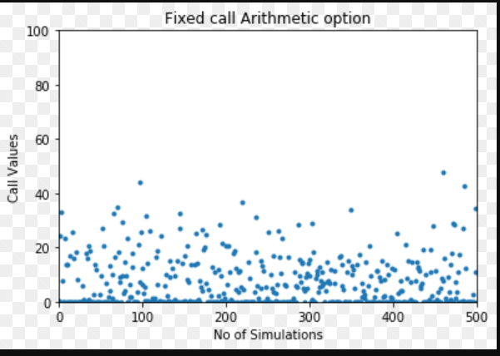

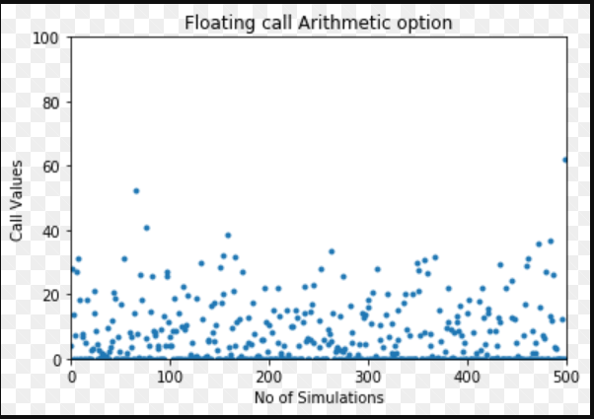

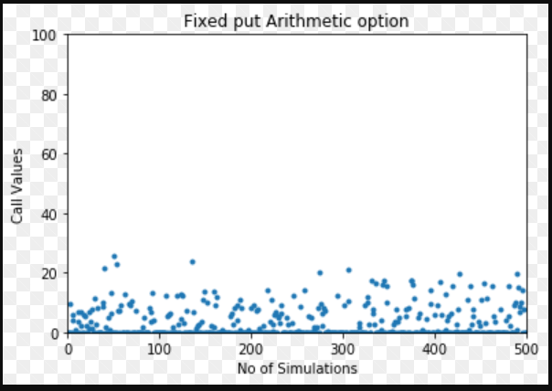

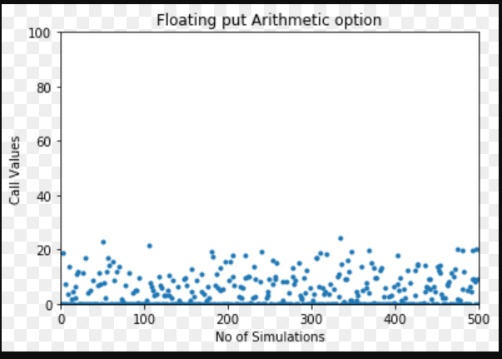

Pseudo Code for **Asian arithmetic Call option:**

Sumulated_avg_option=0

for j=1 to simulation:

set sumst=0

for i=1 to n:

Simulate St

Set sumst=sumst+ St

End for

Average_st= sumst/n

Sumulated_avg_option= Sumulated_avg_option +max(mod(Average_st-E,0)

Call_Opt_value= (Sumulated_avg_option/ simulation)*(discounting factor)

Pseudo Code for **Asian Geometric Call option:**

Sumulated_avg_option=0

for j=1 to simulation:

set sumst=0

for i=1 to n:

Simulate St

Set sumst=sumst+ log(St)

End for

Average_st= exp(sumst/n)

Sumulated_avg_option= Sumulated_avg_option +max(mod(Average_st-E,0)

Opt_value= (Sumulated_avg_option/ simulation)*(discounting factor)

Below results shows the difference between European vanilla call option and Asian Arithmetic call Fixed strike option.

|  |  |  |
| --- | --- | --- |
|  | No. of Simulations(100) | |
|  | European Call Option | Asian Arithmetic call Fixed strike option |
| Option Value | 10.4749 | 6.004635415 |
| Standard Error | 1.89369 | 0.853071685 |

The value of Asian option is very low compared to pure vanilla option due to averaging factor. Standard error is also very less which implies that standard deviation is also very low compared to vanilla option.

**Conclusions:**

In this module exam we learned about how to simulate 16 different variants of Asian options by writing the code in Python and simulating with different numbers. While writing the code there was lot of confusion aroused while differentiating between fixed strike and floating strike puts and calls. But after some analysis found some similarities among them. At expiration if the strike price is same as underlying stock then floating call strike is equivalent to fixed put strike, where Fixed call strike is equivalent to floating put strike. As per the Exotic options extra notes we can theoretically show that the C(fixed Arithmetic ) is greater than or equal to C(fixed Geometric) etc. But through simulation results we can’t prove that because the results are generated through random number. As the number of simulations decrease the Standard Error Increase.

References:

CQF Exotic Options Extra Notes

<https://www.youtube.com/watch?v=a8Cv-tVJLRY>

Module 3 Workshop